**Design a digital circuit that counts the number of 1’s in a 7-bit shift register. You should use T flip-flops for your circuit. Your circuit should display the value on a seven segment display. (Note that you do not need to design the seven segment display decoder, you can use the following decoder.)**

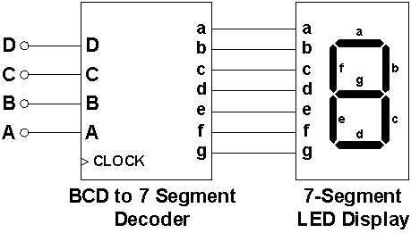

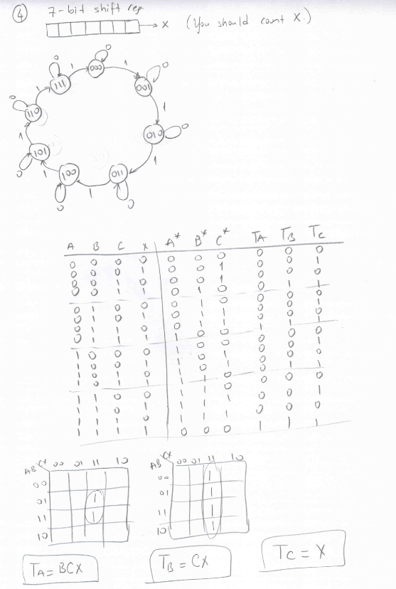

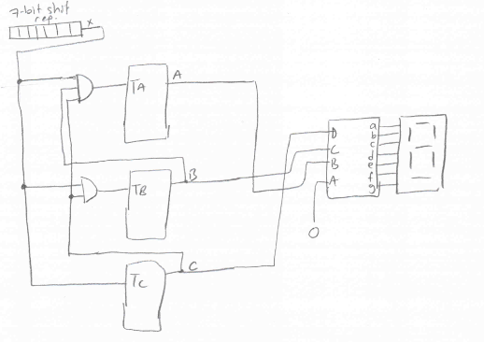

Design a *four-bit universal shift register* that operates the following modes in the given order. Draw the circuit. Show the function table.

Register operations: 0 → Set to zero

1 → Shift right

2 → No change

3 → Load parallel data

4 → Shift left

5 → No change

6 → Complement

7 → Set to 1.

